Axios Methods and Features Explained

1. GET Method Purpose: Fetch data from a server.
Example:
axios.get('https://api.example.com/users')
.then(response => console.log(response.data))
.catch(error => console.error(error));
Explanation: Retrieves data from the server. Response contains data, status, headers, etc.

2. POST Method Purpose: Send data to create a resource.
Example:
axios.post('https://api.example.com/users', {
name: 'David',
email: 'david@example.com'
})
.then(response => console.log(response.data))
.catch(error => console.error(error));
Explanation: Sends JSON/form data to create new records.

3. PUT / PATCH Methods Purpose: Update an existing resource.
PUT (full update):
axios.put('https://api.example.com/users/1', {
name: 'David Updated',
email: 'david@example.com'
});
PATCH (partial update):
axios.patch('https://api.example.com/users/1', {
name: 'David Patched'
});
Explanation: PUT replaces the entire resource, PATCH updates specific fields.

More Explanations
PUT – Will update the whole object that’s why the userd id will be gone I the example below after updating using put
Eg.
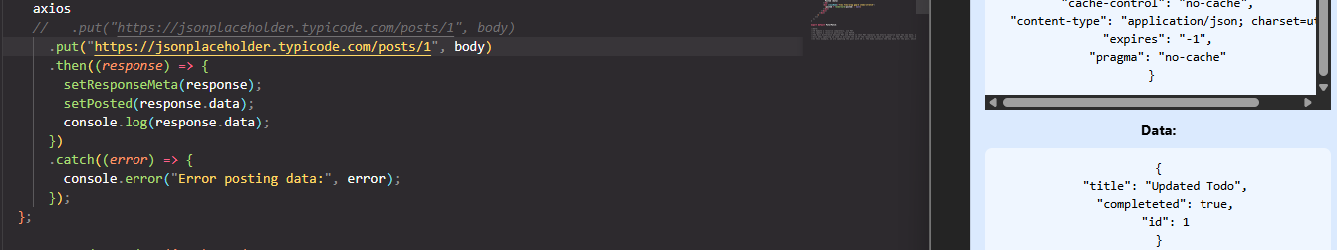
While
PATCH – Will Update only a specified sector that why the userd id will still be there
Eg.
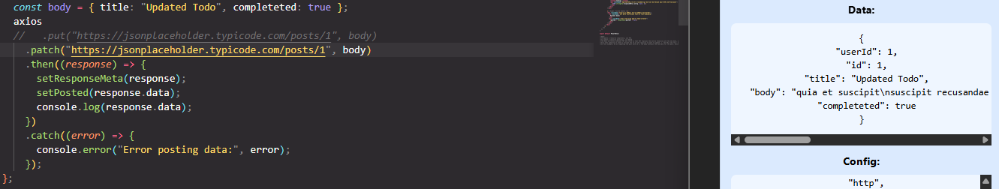

4. DELETE Method Purpose: Remove a resource.
Example:
axios.delete('https://api.example.com/users/1')
.then(response => console.log('Deleted'))
.catch(error => console.error(error));
That’s why it returns an empty object

5. Simultaneous Requests Purpose: Make multiple requests at once.
Example:
axios.all([
axios.get('/users'),
axios.get('/posts')
])
.then(axios.spread((users, posts) => {
console.log(users.data);
console.log(posts.data);
}));
Explanation: axios.all() runs multiple requests; axios.spread() separates responses.

6. Custom Headers Purpose: Send additional metadata with requests.
Example:
axios.get('/user', {
headers: {
Authorization: 'Bearer your_token_here'
}
});
Explanation: Useful for authentication, content type, or custom instructions.

7. Transform Requests / Responses Purpose: Modify request or response data.
Example:
axios({
url: '/user',
method: 'post',
data: { name: 'David' },
transformRequest: [(data) => JSON.stringify(data)],
transformResponse: [(data) => JSON.parse(data)]
});
Explanation: Transform data to match server expectations or process responses.

8. Error Handling Purpose: Manage errors from requests.
Example:
axios.get('/user/123')
.then(response => console.log(response.data))
.catch(error => {
if (error.response) {
console.log('Server responded with status:', error.response.status);
} else if (error.request) {
console.log('No response received:', error.request);
} else {
console.log('Error setting up request:', error.message);
}
});
Explanation: Handles server errors, network issues, or other request errors.

9. Canceling Requests Purpose: Stop a request before it completes.
Example:
const controller = new AbortController();
axios.get('/user/123', { signal: controller.signal })
.then(response => console.log(response.data))
.catch(error => {
if (axios.isCancel(error)) {
console.log('Request canceled:', error.message);
}
});
// Cancel the request
controller.abort();
Explanation: Useful to save bandwidth or prevent outdated responses.

